Introduction to Simple Software

Simple Software helps you create business solution software that will be affordable, easy to use, and help you get the job done, without getting in the way.

Our belief
Simple Software is a hosted web application for creating, linking, and managing business information using nothing but your web browser. From its inception, Simple Software has worked toward making business solutions for companies and non-profit organizations easy to use and manage. Simple Software provides a database-driven platform for clients to create, manage, and use applications for all of their needs.

We believe your attention should be focused on your business, not on your software.

Why choose Simple Software?
Simple Software was chosen because of the ability to build custom web applications without the need for extensive training. Sanrio’s plan is to minimize manual data tasks by building custom solutions using our cutting edge development tools. Going forward, the cost of maintaining and upgrading systems should be weighed against moving these processes to our cloud. Simple Software will not only exceed expectations technically and monetarily, it will reduce development time as well as time spent supporting users. The ability to customize a web solution without the usual cost in time, training and resources will prove to be a substantial return on Sanrio’s investment. Because Sanrio didn’t want to force its employees to conform to software instead Sanrio wanted the software integrated into the way Sanrio workers do things.

- From time cards and inventory management to point-of-sale and customer tracking, Simple Software can help your business streamline your products so that you have time to grow your company. As your company grows, your Simple Software solution grows with it because we make it easy for you to add, update and extend your application.
- Our software has been in production since 1995 and is used by many clients with a wide range of requirements. We design our products to be flexible to your business needs and simple to learn.
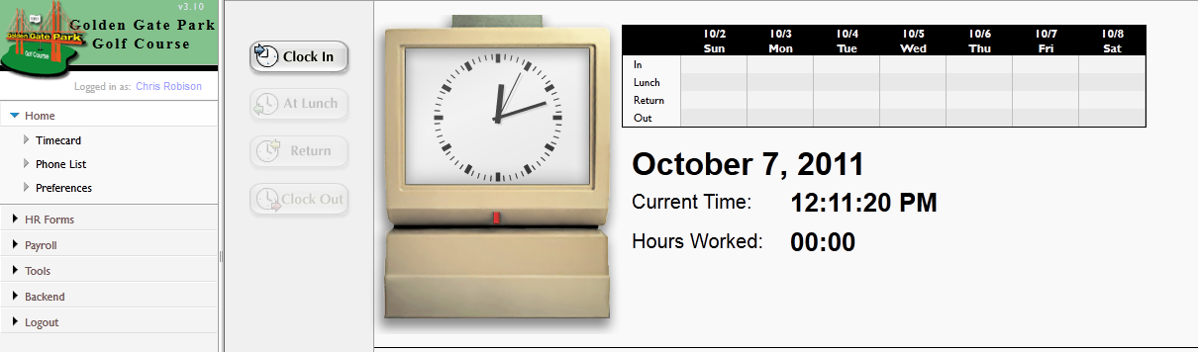

Accessing Simple Software workspace through an internet browser (Firefox 5 or greater)
Navigating your Sanrio workspace
Working with forms and data
Using Sanrio Helpdesk
Tech Support
Online Account
Purchase Request

Day 2: Who needs to attend: The whole Sanrio IT team and HR
Managing Helpdesk Tickets
Tech Support
Assigning Ticket
Online Account
Purchase Request
Quote
PAR
New Employee

Day 3: Who needs to attend: Sanrios IT team that will be administering the App
Simple Software Tools - Administration (1 hour)
Application Manager
Managing Modules/Processes
Adding a new process
User Administration
Creating new user
granting access
File Manager
View existing forms
edit forms
managing files (Graphic design team)
Simple Software Tools - Development (1+ hours)
Advanced Grid/Form interaction
Relating data across processes
import/export
Database Tool
Creating new table
adding columns
importing data
change existing table
update in App Manager
Report a Problem
Contacting Simple Software Support through the application
email support@simplesoftwaresf.com

